The document provides information about RK-SpecRecon and SK-SpecRecon tools designed for spectra separation within the context of DMI. These tools find specific application in the ME-SSFP and CSI-SSFP sequences.

For additional information regarding this tool, kindly reach out to the authors at:

* elton.montrazi@gmail.com
* lucio.frydman@weizmann.ac.il
* <https://github.com/montrazi>
* <https://www.weizmann.ac.il/chembiophys/Frydman_group/software>

**About RK-SpecRecon and SK-SpecRecon:**

Montrazi ET, Bao Q, Martinho RP, Peters DC, Harris T, Sasson K, Agemy L, Scherz A, Frydman L. Deuterium imaging of the Warburg effect at sub-millimolar concentrations by joint processing of the kinetic and spectral dimensions. NMR Biomed. 2023 Jul 4:e4995. doi: 10.1002/nbm.4995. Epub ahead of print. PMID: 37401393.

**About ME-SSFP sequence:**

Peters DC, Markovic S, Bao Q, Preise D, Sasson K, Agemy L, Scherz A, Frydman L. Improving deuterium metabolic imaging (DMI) signal-to-noise ratio by spectroscopic multi-echo bSSFP: A pancreatic cancer investigation. Magn Reson Med. 2021 Nov;86(5):2604-2617. doi: 10.1002/mrm.28906. Epub 2021 Jun 30. PMID: 34196041.

**About CSI-SSFP sequence:**

Nature communication

**IDEAL – ME-SSFP**

%%% ME-SSFP demo %%%

sequence='me-ssfp';

b0map=7; %fieldmap folder, # or 'no'

expseq=[8 11 13 15 17 19 21 23 25 27 29 31 33 35 37 39 41 43 45 47 49 51 53 55 57 59]; %ssfp folders

method='ideal';

%%%%%%%%%%%%%%%%%%%%



**RK-SpecRecon – ME-SSFP**

%%% ME-SSFP demo %%%

alpha=10; FirstPointReg=[1 0 1]; %zero to remove regularization from the first to second metabolic map

method='rk-ideal';

%%%%%%%%%%%%%%%%%%%%



**RK-SpecRecon – ME-SSFP**

%%% ME-SSFP demo %%%

timeexp=[0 6.38 13.87 21.37 28.87 36.37 43.87 51.37 58.85 66.33 73.83 81.33 88.85 96.35 103.87...

111.38 118.9 126.4 133.92 141.43 148.95 156.45 163.98 171.5 179.03 186.52]; %time for each ssfp (needed for SK-SpecRecon)

if strcmp(method,'sk-ideal')

K=4; Phi_matrix=Phi_generator_SK_SpecRecon(timeexp,K);

end

method='sk-ideal';

%%%%%%%%%%%%%%%%%%%%

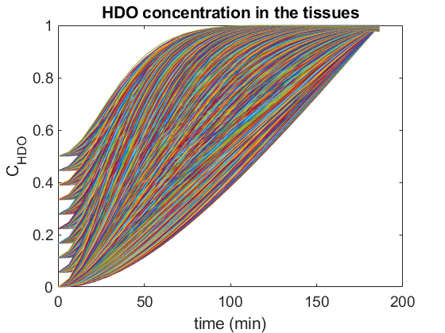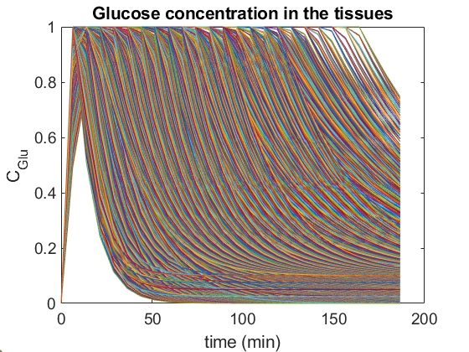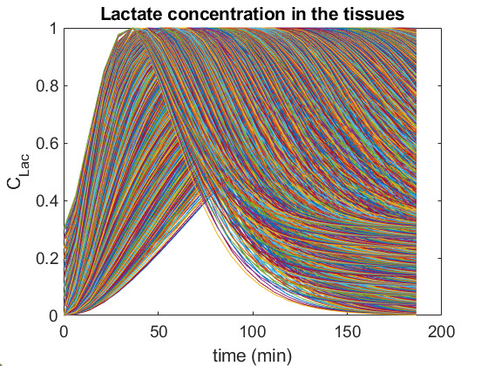



**IDEAL – CSI-SSFP**

%%% CSI-SSFP demo %%%

sequence='csi-ssfp';

b0map='no'; %fieldmap folder, # or 'no'

expseq=[8 11 13 15 17 19 21 23 25 27 29 31 33 35 37 39 41 43 45 47 49 51 53 55 57 59 61]; %ssfp folders

method='ideal';

%%%%%%%%%%%%%%%%%%%%%



**RK-SpecRecon – CSI-SSFP**

%%% CSI-SSFP demo %%%

method='rk-ideal';

alpha=10; FirstPointReg=[1 0 1]; %zero to remove regularization from the first to second metabolic map

method='rk-ideal';

%%%%%%%%%%%%%%%%%%%%%

